BUILD SERVER

  - Operational concept document

  - PROJECT #4
CSE 681 SOFTWARE MODELING AND ANALYSIS
Submitted By: Jing Qi
SUID: 462324839
Term: Fall 2017
Date: 6th Dec 2017
Contents
1. INTRODUCTION 2
1.1 executive summary 2
2. CONCEPT STATEMENT 2
2.1 features 4
3. SYSTEM STRUCTURE 5
3.1 Pluggable comm 5
3.2 Client mock 8
3.3 repository mock 10
3.4 Build Server 12
3.5 Test harness mock 15
4. POTENTIAL USERS AND USES OF BUILD SERVER 17
4.1 users 17
4.2 uses and gui 17
5. PROJECT PROCESS 23
6. CRITICAL ISSUES 24
6.1 multi-languages 24
6.2 portable comm 24
6.3 QUEUE PROCESSOR 24

INTRODUCTION
The following is an Operational Concept Document describing the conception of the development on an automated build server system, capable of building C# libraries, using a process pool to conduct multiple builds in parallel. This document introduces you the key takeaways from initial prototyping to architecture work like packages structures. It also provides the detail uses of the system which would guide project design. If you have any questions, comments, or concerns regarding this document, please contact the author Jing Qi via email at zzzgin@hotmail.com.

executive summary
In industry cases, a project usually consists of thousands or even millions of files., modules or packages. Most of them are some small projects being stored in the repository to be included in the software baseline. As the result of the importance to ensure the code is functional and the ‘include tree’ is correct, a test is required. But before the ‘code’ being sent to the Test Harness Server, it should be built to an executable programs or DLL programs with the included files in repository. A Build Server is a tool for this task.
This build server system provides an automatic mechanism to get the build request from the client, check the file list in the build request and gather them form the repository. Then, the build server would automatically get these gathered files built to a DLL file and generate a test request and sent it to the test harness. With the information provided from the test request, the test harness would gather all the DLL files and do specific tests defined by coders. For the control of this whole process, a client program should be provided. This client program make control of what file should be built and weather the build request should be sent.
Not only the software companies, other industries who need to deal with mountains of codes need this system because it would be low efficiency without a centralized repository-build-test system.

CONCEPT STATEMENT
This system consists of 4 parts as said before:
- Client Program:
This part provides the basic control of file flow. For example, when a user needs to upload some code to the base line, she\he can open this program and select those code files and upload to the remote repository. When she\he wants to add those code to the base line, she\he can choose the file in the repository and make a build request and send it to the build server.
For easy-use, this program should have a GUI built by WPF.
- Repository Server:
This part is designed as a remote server. It serves as a remote code, logs, requests, and base line warehouse. In this system, the storage should be carefully managed because it needs an efficient way to distinguish all the different files.
But in this project, we just need a repository mock to illustrate the work of build server. It should provide the functions of communication and file transfer.
- Build Server:
This part is the main design of this project. It connects with repository to get the files and build request. It communicates with client program to show the result of building. It provides DLL files for test harness to make further test.
Furthermore, multiple child builder should be provided which can work simultaneously. To manage the tasks flow, a blocking queue should be provided. Whenever a child builder is idle, it would be send to a queue for further tasks.
- Test Harness:
This part is designed as a remote server too. It gathers DLL files from build server and do the test designed by code writers. All the codes upload to test harness should inherit a special file which defines the test case.
Meanwhile, a test case should provide a test driver and one or more tested files. The test driver works as a main function entrance. The tested files provide test classes and would be tested one by one by test harness.
Same as repository server, in this project, we make a test harness mock coordinating with build server.

The relationship of above four parts is clearly seen in Fig.1.
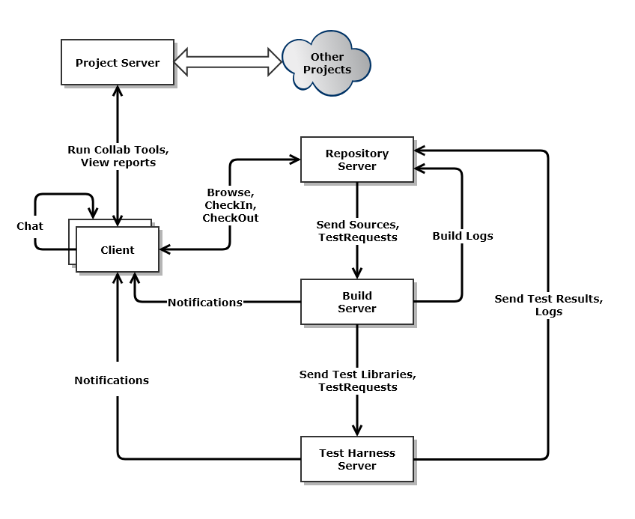
Fig. 1 Software Collaboration Federation

features
This builder server system provides following features to its users:
- Capable of building different coding languages like C++, C#, JAVA etc.
- Capable of making and reading XML files from Repository Server and Test Harness.
- Has a queue system which manages the building tasks.
- Build results should be displayed to the user on the GUI program and be saved as a log in the repository
- Multiple child builders should be provided to face the use of heavy load.

SYSTEM STRUCTURE
In this section, we provide the structure of each parts and finally give out the structure of the whole system.

Pluggable comm
As introduced before, the project is divided into 4 parts. Each part communicates with each other by pluggable comm.
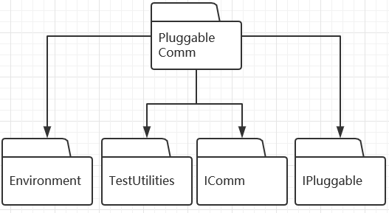
Fig.2: Pluggable Comm Package Diagram
The inherit relationship of related packages is shown above (Fig.2).
Environment: define the parameter of comm environment. Such as the storage root, end point, port and so on.
TestUtilities: a package used for testing and console writing.
IComm: interface defines the main functions of comm.
IPluggable: interface defines the main functions of the “pluggable” feature.
PluggableComm: the main package of this parts. It defines the functions of Pluggable Comm. It also has define the functions of Blocking Queue.
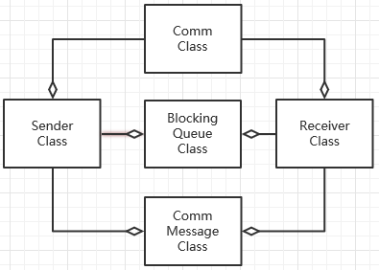
Fig.3 Pluggable Comm Class Diagram
The main classes relationship is shown above in Fig.3.
Comm message class: defines the message which would be sent in comm.
Sender class: opens channel and attempts to connect to an endpoint.
Receiver class: creates instance of a host and deals with incoming message
Blocking Queue class: define a blocking queue which be used in sending and receiving.
Comm class: includes a sender and a receiver, which combine as a Comm.
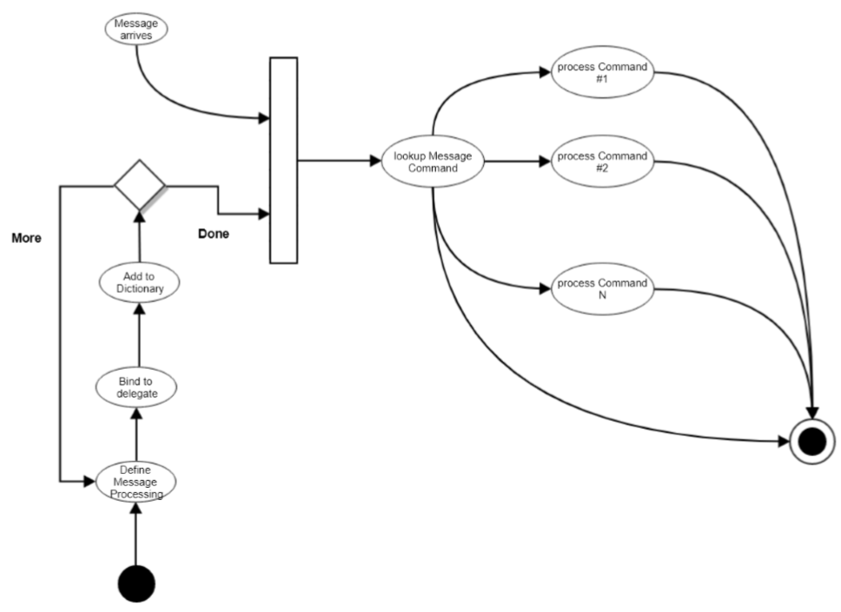
Fig.4 message dispatcher activity diagram
Message dispatching activity diagram is shown as above(Fig.4).

Client mock
Fig.5 Client Packages Diagram
The client package diagram is shown above.
Fig. 6 Client Classes Diagram
The client classes diagram is shown above.
Window class: the main function which controls the GUI.
Most of the following classes works for Comm.
Fig. 7 Client Activities Diagram
The client activities diagram is shown above.

repository mock
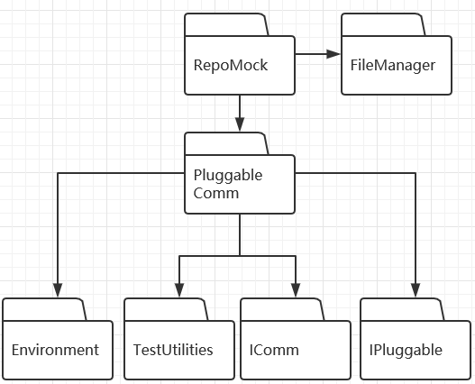
Fig. 8 repository mock package diagram
Repomock defines a navigator server which can return file and dir information to other comm endpoint as a message.
Filemanager works for directory searching and file managing.
The most of rest is parts of Comm.
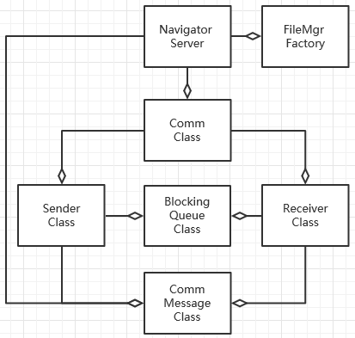
Fig.9 Repository Mock Class Diagram
This is some kind of similar with package diagram.
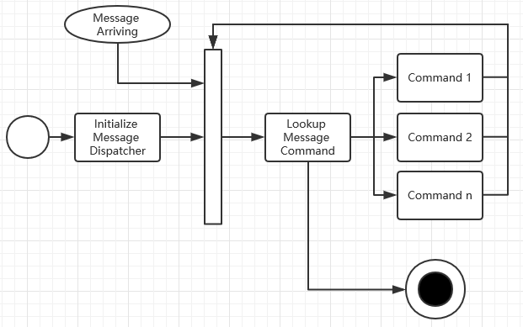
Fig. 10 Repository Mock Activity Diagram
It’s a little similar to the message dispatching activity diagram (Fig. 4). This process keeps rolling to wait message until quit message arrives.

Build Server
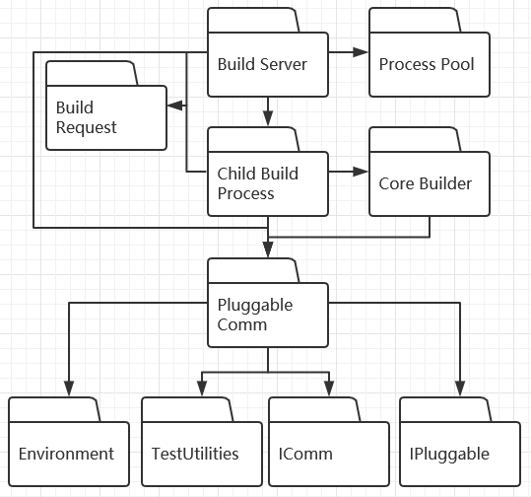
Fig. 11 Build Server Package Diagram
Build Server works as a mother builder to generate, manage, and connect the child build process.
Child build process works as a loop to get message (build request) from build server.
Core Builder defines a class which take file name as an input and build a DLL file as an output.
Build request define the functions of build request.
Process pool defines a structure which manage the ready-request queue and assign tasks.
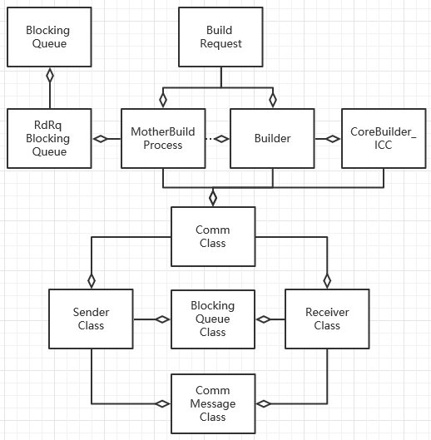
Fig. 12 Build Server Class Diagram
RdRqBlockingQueue Class is a structure (Fig.13) based on blocking queue and can manage the ready queue and request queue for assigning tasks to child builder.
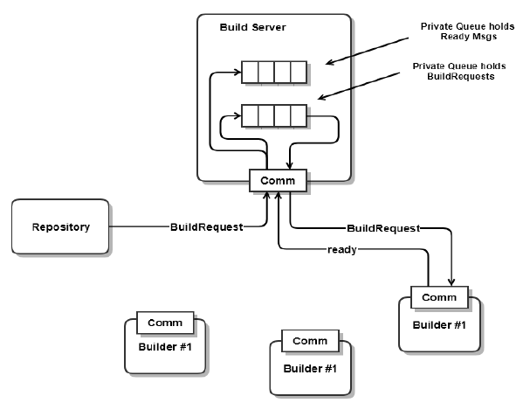
Fig. 13 concept of Process pool
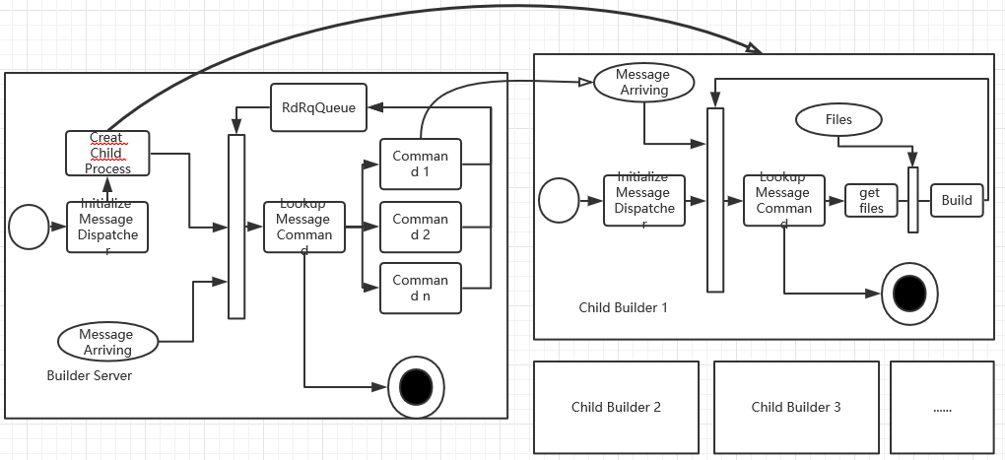
Fig .14 Build Server Activity Diagram
Picture shown above is Build Server Activity Diagram (Fig. 14).
The essence of build server is also a message despatcher which do some reactions (here, send build request to child builders and so on). Before going to the message dispatching loop, it creates some child builders.
The child builder gets build request from builder Server and try to gather files from repository. When all the file is gathered, it would build those files and then wait for another task.

Test harness mock
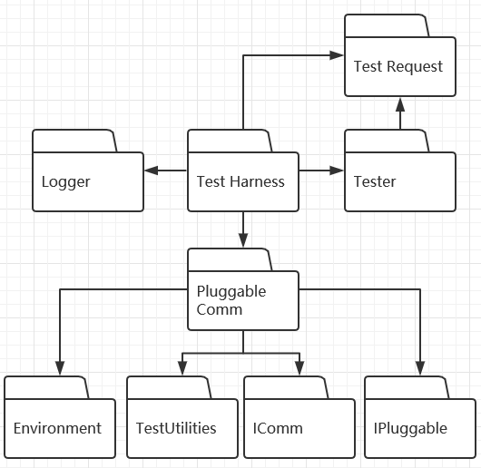
Fig. 15 Test Harness Mock Package Diagram
Test harness includes a main function of Test Harness Mock.
Tester is a package define the function which tests the DLL file.
Logger deals with the test request.
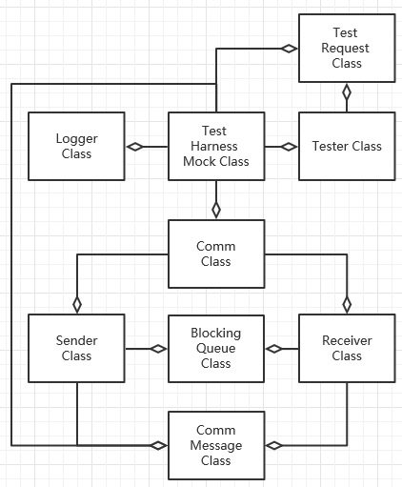
Fig. 16 Test Harness Mock Class Diagram
Fig. 16 Test Harness Mock Activity Diagram

POTENTIAL USERS AND USES OF BUILD SERVER

users
Developers are the most frequent users of the Build Server. When they finish some modules, usually they would find a way to test them. To do that, they can upload their source file (.cs) with a config file (here is Build Request) to the repository. When the building is fail, a message would be sent to client GUI. If success, the builder gives out a test request to the Test harness and do the test. If the test is success, the application would show a ‘success’ message. Otherwise, a test error message would be shown.

uses and gui
Only the client GUI has a WPF GUI. Other mock servers are console application. At the start of the application, the UI of those mock servers and build server is like:
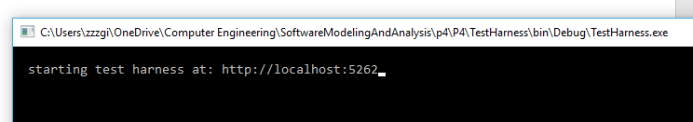
Fig. 17 TestHarness UI

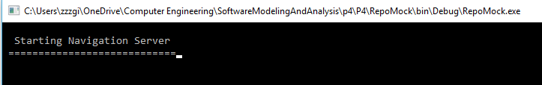
Fig. 18 RepoMock UI
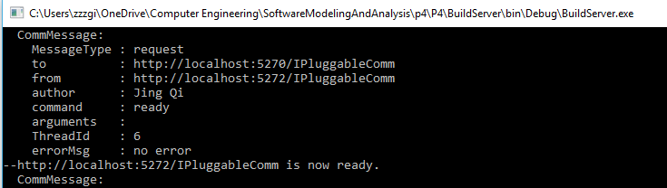
Fig. 19 BuildServer UI

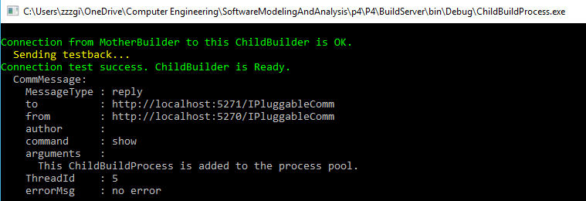
Fig.20 One of the ChildBuildProcess UI
Which needs to be mentioned is that at the start of the application, the build server creates some Child Builders and test the connection, which shows some messages in the UI.
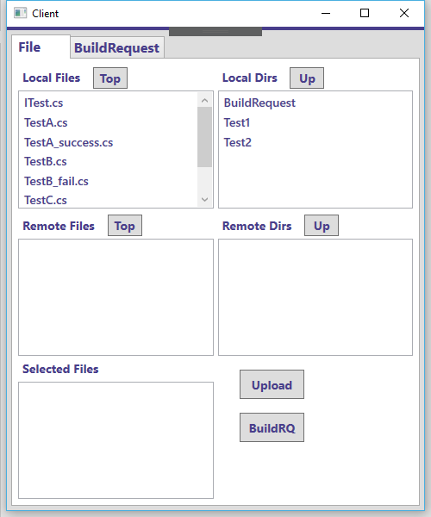
Fig. 21 The GUI of client program
The two list boxes above show the files and direction in local. You can control the direction by clicking the “top” and “up” button.
When you want to upload some files, you can select one (I don’t have time to make the feature that you can multi-select files in list box) file in the Local Files List Box and click on “upload”.
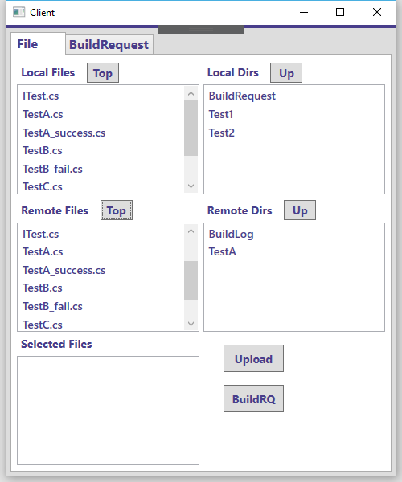
Fig. 22 Upload the local file.
For example, you want to build the TestA. You can double click the files in Remote Files list box and the file would be added to the Selected Files list box. If you select the wrong file, relax, you can double click on the file in Selected files list box and delete the file you select.
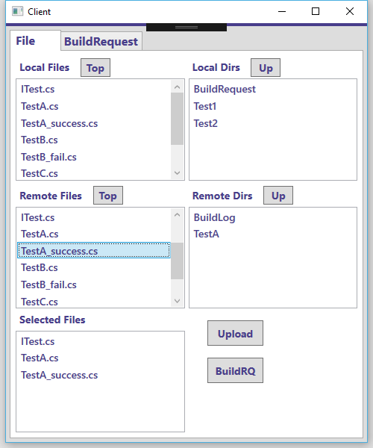
Fig. 23 Select the files
When you check the files are all the files you want to build, you can click on the “BuildRQ” and generate a new BuildRequest in Repository. Now you can see the BuildReqeust in the “BuildRequest” tab.
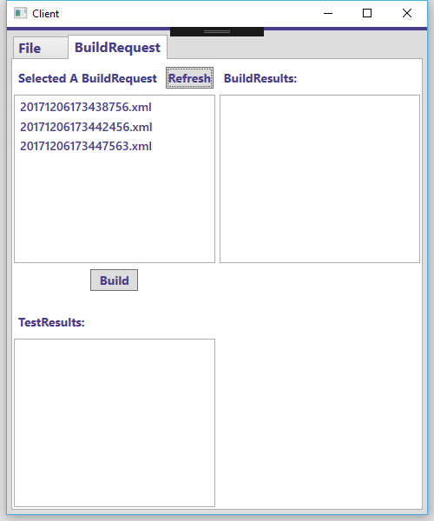
Fig. 24 3 test case is made into BuildRequest
Now, you want to build and test the test case. You can just select one build request and click on “Build”. Wait for a second and you would get the result in “buildResults” and “TestResults” list boxes.
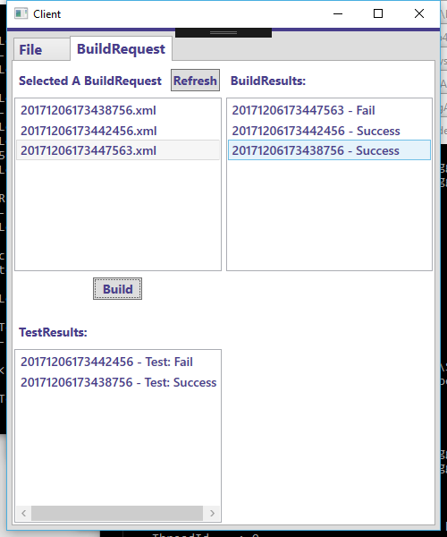
Fig. 25 the results of these 3 test cases
We can see that the first buildrequest (end with 8756) is built success and test success.
The 2nd build request (end with 2456) is built success and test fail.
The 3rd build request (end with 7563) is build fail and have no test result.
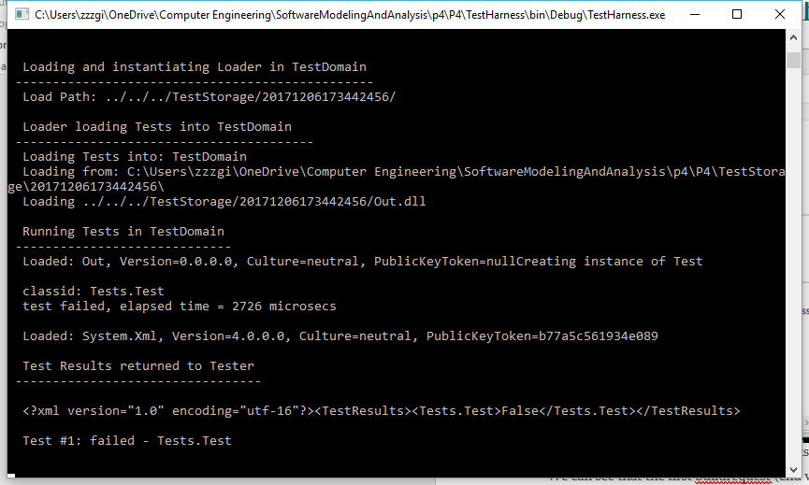
Log. 26 the test log in testHarness UI

PROJECT PROCESS
The first, Project #2, implements a local Build Server that communicates with a mock Repository, mock Client, and mock TestHarness, all residing in the same process. Its purpose is to allow the developer to decide how to implement the core Builder functionality, without the distractions of a communication channel and process pool.
The second, Project #3, develops prototypes for a message-passing communication channel, a process pool, that uses the channel to communicate between child and parent Builders, and a WPF client that supports creation of build request messages.
Finally, the third stage, Project #4, completes the build server, which communicates with mock Repository, mock Client, and mock TestHarness, to thoroughly demonstrate Build Server Operation.

CRITICAL ISSUES
When we meet the industry needs, the performance of the code manage system must be optimized. Especially, the building stop is usually a time-consuming process. A series of works must be stopped until the test libraries are build. As a result, it is very important to make the build server run smoothly.

multi-languages
Description: in the real industry, a project may be completed in different languages. Or, in a company, different projects may be coded by different languages. So a single-language build server system would not fit the requirements of real industry.
Solutions: we can add different builder in the “CoreBuilder” package. In my code, I reserve place for C++ and Java. But lacking of time, I don’t finish them.

portable comm
Description: as can be seen in the system structure, a portable comm is very important for this project because almost all parts of this project is designed as a remote server and the communication between them should be based on COMM. If COMM is not portable, the code would have a high-coupling.
Solutions: we design two Interfaces. One is IComm and the other one is IPortable. We make our ProtableComm class inherit from these two interfaces and we can get the features we want.

QUEUE PROCESSOR
Description: in our project, many processes are based on queue. But when it comes to thread, it is dangerous because of deadlock or other issues. So we have to design a Blocking queue. For the task assignment, we need another kind of blocking queue which contains two queues.
Solutions: as the description above, the two-Blocking-queue can use the design of blocking queue. We can define two blocking queue and one locker, any queue is locked, both of them is locked.

Jim Fawcett. http://ecs.syr.edu/faculty/fawcett/handouts/CSE681/Lectures/Project4-F2017.htm
Jim Fawcett https://ecs.syr.edu/faculty/fawcett/handouts/CSE681/MidTerm/MTF17/MT1F17-InstrSol.pdf
Jim Fawcett https://ecs.syr.edu/faculty/fawcett/handouts/CSE681/MidTerm/Diagrams/
Jim Fawcett https://ecs.syr.edu/faculty/fawcett/handouts/CSE681/MidTerm/Diagrams/
Jim Fawcett https://ecs.syr.edu/faculty/fawcett/handouts/CSE681/MidTerm/Diagrams/
Jim Fawcett https://ecs.syr.edu/faculty/fawcett/handouts/CSE681/MidTerm/Diagrams/
Jim Fawcett https://ecs.syr.edu/faculty/fawcett/handouts/CSE681/MidTerm/MTF17/MT1F17-InstrSol.pdf

